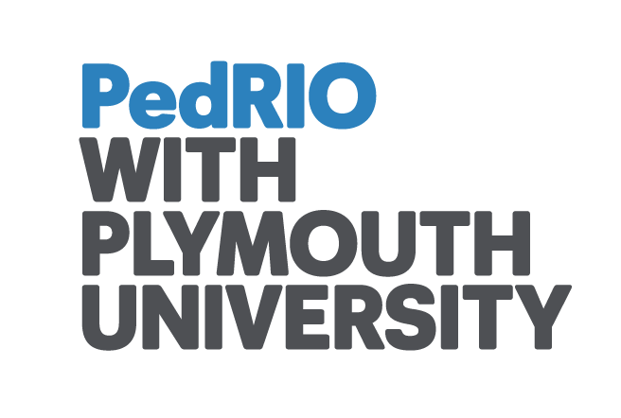

PedRIO/TFAS Funding Award: Project Completion Form

Please return this form to pedrio@plymouth.ac.uk

1) Title of project:

2) Name of project leader: Dr Richard Ayres

Department/school/faculty: PCMD/PUPSMD

Telephone: 01752586825

E-mail: richard.ayres@plymouth.ac.uk

3) Names of other staff involved: Maria Tighe, Sebastian Stevens

4) Total project spending: £7820

4) Keywords (that describe/reflect the project): Social engagement, interprofessional education

5) Main findings/results (approx. 250-500 words which may be used on the extranet or other PR): See main report. Abstract reproduced here

Abstract
Purpose
It is increasingly recognised that medical schools have a duty to the communities that they serve and that there are many benefits in student social engagement within those communities. There is also ongoing interest in the value of inter - professional working. Social engagement has many forms, and benefits to students are likely to be multi-faceted. We chose to use a previous classification of social engagement into community-orientated, community-based and community engaged education. We used a conceptual model of benefit derived from the work of MacIntyre. In this model, engagement is seen as a “practice” that brings benefits to both students and patients in the form of “internal and external goods”
Methods
The project provided 1) interdisciplinary attachments for student volunteers from medicine and nursing disciplines to 3 community-based providers and 2) An opportunity for students from 10 healthcare disciplines to collaboratively run a whole day health promotion event at a health facility in an area of high social deprivation.
Extensive qualitative data from student diaries, interviews with students and staff and focus groups were collected and analysed thematically.
Results
Students gained new insights, knowledge and skills arising from both the community experience and from working with different disciplines. They were able to contribute in diverse and sometimes unexpected ways. A number of “internal goods” such as development of deeper relationships, communication of feelings, breaking down of class and professional barriers resulted.
Conclusions
The 2 components of the project provided different but complementary experiences. It is clear from the data that students enjoyed the often new experience of working with peers from other disciplines. They also enjoyed, but were greatly challenged by, working with service users with multiple and complex needs (such as when they were placed with providers working with homeless persons). There was strong evidence of new learning and clear examples of change of practice resulting from these experiences. We considered that the project provided mostly community-based but some community-engaged experiences. Philosophically, sending healthcare students into communities represents a radical change of practice for medical and nursing schools and the “MacIntyre” model provided a very useful conceptual framework for understanding the process, as well as the outcomes that can be achieved. Further work is ongoing.

6) If the project has a dedicated website, please provide the URL:

7) If the project required ethical approval, please inform us of the date the approval was received and the body through which it was granted:
University of Plymouth Ethics Committee 25/11/2014

8) A summary of the required outputs of projects receiving funding awards can be found below. Please attach the relevant documents (demonstrating these outputs) when returning this form. Use the space below to provide any further information where necessary, and to provide information on unexpected outputs (where relevant).

- A minimum of one peer reviewed journal article (draft or final/published work)

This is currently draft and to be submitted (see final report)

- Evidence of dissemination at national / international research conferences
See confirmations for AMEE, ASME and PEDRIO conferences
Also
7th March 2016. ‘Inter-professional Health Students and Social Engagement’.
Plymouth University Conference, ‘Health and Social Care Integration: Making it Real’

7th April 2016. ‘Inter-professional Placements Across the Health Disciplines to Enhance Future Understanding and Collaboration’.
Annual Learning and Teaching Conference, University of Sheffield.

- Evidence of contributions to PedRIO / Teaching and Learning events
As above

- Other outputs (where relevant)

